

CHEMISTRY

UNIT 3 & 4

2020

Name: _________________________________________________________________________________________

# TIME ALLOWED FOR THIS PAPER

## Reading time before commencing work: ten minutes

Working time for the paper: three hours

# MATERIALS REQUIRED/RECOMMENDED FOR THIS PAPER

**To be provided by the supervisor:**

This Question/Answer Booklet

Multiple-choice Answer Sheet

Chemistry Data Booklet

**To be provided by the candidate:**

Standard items: pens (blue/black preferred), pencils (including coloured), sharpener,

eraser, correction tape/fluid, ruler, highlighters

Special items: non-programmable calculators approved for use in the WACE examinations

# IMPORTANT NOTE TO CANDIDATES

No other items may be taken into the examination room. It is **your** responsibility to ensure that you do not have any unauthorised material. If you have any unauthorised material with you, hand it to the supervisor **before** reading any further.

**Structure of this paper**

|  |  |  |  |  |  |
| --- | --- | --- | --- | --- | --- |
| Section | Number of questions available | Number of questions to be answered | Suggested working time  (minutes) | Marks available | Percentage of examination |
| Section One  Multiple-choice | 25 | 25 | 50 | / 25 | / 25 |
| Section Two  Short answer | 9 | 9 | 60 | / 76 | / 35 |
| Section Three  Extended answer | 6 | 6 | 70 | / 97 | / 40 |
|  | | | | | / 100 |

**Instructions to candidates**

1. Write your answers in this Question/Answer booklet preferably using a blue/black pen. Do not use erasable or gel pens.

2. Answer the questions according to the following instructions.

Section One: Answer all questions on the separate Multiple-choice answer sheet provided. For each question, shade the box to indicate your answer. Use only a blue or black pen to shade the boxes. Do not use erasable or gel pens. If you make a mistake, place a cross through that square then shade your new answer. Do not erase or use correction fluid/tape. Marks will not be deducted for incorrect answers. No marks will be given if more than one answer is completed for any question.

Sections Two and Three: Write your answers in this Question/Answer Booklet.

3. When calculating numerical answers, show your working or reasoning clearly. Your working should be in sufficient detail to allow your answer to be checked readily and for marks to be awarded for reasoning. Express numerical answers to the appropriate number of significant figures and include appropriate units where applicable.

4. You must be careful to confine your answers to the specific questions asked and to follow any instructions that are specific to a particular question.

5. Supplementary pages for planning/continuing your answers to questions are provided at the end of this Question/Answer booklet. If you use these pages to continue an answer, indicate at the original answer where the answer is continued, i.e. give the page number.

6. The Chemistry Data booklet is not to be handed in with your Question/Answer booklet.

**Section One: Multiple-choice 25% (25 marks)**

This section has **25** questions. Answer **all** questions on the separate Multiple-choice Answer Sheet provided. For each question, shade the box to indicate your answer. Use only a blue or black pen to shade the boxes. If you make a mistake, place a cross through that square then shade your new answer. Do not erase or use correction fluid/tape. Marks will not be deducted for incorrect answers. No marks will be given if more than one answer is completed for any question.

Suggested working time: 50 minutes.

**Questions 1 and 2 refer to the energy profile diagram below.**

1. The reaction represented by the **solid** line

1. is exothermic.
2. has an activation energy of +200 kJ.
3. has an enthalpy change of +350 kJ mol-1.
4. involves a gain in energy by the system.

2. When compared to the reaction represented by the solid line, which of the following statements is **not** correct regarding the reaction represented by the **dashed** line?

1. It would occur at a faster rate.
2. It would have a lower enthalpy change.
3. It would have a lower activation energy.
4. It involves an alternate reaction pathway.

3. Determine the pattern for the oxidation number of **manganese** in the following compounds.

Mn(s), MnCl2(aq), MnO2(s), __________

Select the compound that would continue this pattern.

1. Mn2O7
2. MnF3
3. Mn2O3
4. K2MnO4

4. Consider the three (3) compounds below.

**X Y Z**



Classify each compound correctly, according to functional group.

**Amine Amide Amino acid**

1. Z Y X
2. X Z Y
3. Z X Y
4. Y X Z

5. Which of the following polymers is able to form hydrogen bonds between its chains?

1. Polyethene
2. Polytetrafluoroethene
3. Nylon 6,6
4. Polyethylene terephthalate

6. A detergent ion does **not** contain

1. a non-polar hydrocarbon region.
2. a benzene ring.
3. a charged COO- group.
4. a charged SO3- group.

7. Which of the following statements is **not** true for bothgalvanic and electrolytic cells?

1. Reduction occurs at the cathode.
2. Cations migrate towards the positive electrode.
3. Electrons move from the anode to the cathode.
4. Electrodes may be inert or reactive.

**Questions 8 and 9 refer to the chemical synthesis reaction sequence shown below.**

Ethene

Ethanol

Ethanoic acid

Ethyl ethanoate

**A**

**B**

**C**

8. Name the processes occurring at A, B and C.

**A B C**

1. hydration oxidation esterification
2. oxidation addition esterification
3. addition hydration hydrolysis
4. hydration oxidation hydrolysis

9. Which catalyst needs to be added at A, B and C for the reactions to proceed as indicated?

1. H2SO4
2. H2O
3. NaOH
4. H2O2

10. The indicator M-Nitrophenol is used for an acid-base titration.

0 1 2 3 4 5 6 7 8 9 10 11 12 13 14

pH

|  |  |
| --- | --- |
| colourless | yellow |

Select the option below that lists the appropriate solution in each flask and the corresponding colour change that would be observed.

**Burette Conical flask Colour change**

1. KOH(aq) CH3COOH(aq) colourless to yellow
2. HCl(aq) NH3(aq) yellow to colourless
3. HF(aq) NaOH(aq) colourless to yellow
4. Ba(OH)2(aq) HNO3(aq) yellow to colourless

11. When an aqueous solution of KBr is electrolysed, the product formed at the anode is:

1. K(s).
2. H2(g).
3. Br2(*l*).
4. O2(g).

**Questions 12 and 13 relate to the Haber process.**

The Haber process can be represented by the chemical equation below.

N2(g) + 3 H2(g) ⇌ 2 NH3(g) + 92 kJ

12. Periodically, the ammonia is removed from the reaction chamber. What **immediate** effect would this have on the rate of reaction?

1. The forward reaction rate would increase.
2. The reverse reaction rate would increase.
3. The forward reaction rate would decrease.
4. The reverse reaction rate would decrease.

13. Which of the following conditions will maximise **both** the rate of formation and equilibrium yield of ammonia?

1. An increased concentration of reactants
2. An increased pressure caused by a decrease in volume
3. An increased temperature
4. Addition of a catalyst

(a) (i) and (ii) only

(b) (ii) and (iii) only

(c) (i) and (iv) only

(d) all of (i), (ii), (iii) and (iv)

14. During the process of electrorefining impure (blister) copper, several different metal impurities are removed. Which statement is **incorrect** regarding the various metal impurities found in blister copper?

1. Ag would be found in the anode slime.
2. Zn would be oxidised to Zn2+(aq).
3. Ni would be found in the anode slime.
4. Fe would be oxidised to Fe2+(aq).

15. Select the correct IUPAC name for the molecule shown below.



1. 2,5,5-tribromo-1-methylpentanal.
2. 1,1,4-tribromohexan-5-one.
3. 2,5,5-tribromohexan-2-one.
4. 3,6,6-tribromohexan-2-one.

16. A chemist carried out an experiment to investigate the auto-ionisation of water.

H2O(l) + H2O(l) ⇌ H3O+(aq) + OH-(aq)

The data collected by the chemist is shown in the graph below.

Which of the following hypotheses is **not** directly related to the data collected in this experiment?

1. An increase in water temperature will favour the forward reaction.
2. An increase in water temperature will increase the forward reaction rate.
3. The auto-ionisation of water is exothermic.
4. The concentration of H3O+(aq) in water is temperature-dependant.

17. The following diagram has been taken from the Protein Data Bank (PDB). It shows the structure of the ‘orange carotenoid protein’ which is a dimer consisting of two proteins.

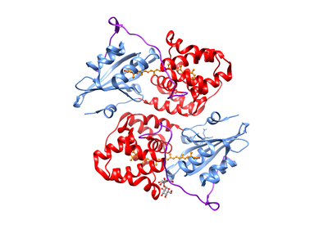

protein unit 1

protein unit 2

This type of ‘ribbon structure’ provides **least** information about the

1. primary structure of the protein.
2. secondary structure of the protein.
3. tertiary structure of the protein.
4. protein-protein interactions.

**Question 18 refers to the information in the table below.**

|  |  |  |
| --- | --- | --- |
|  | Boiling point | Solubility in water at 20 °C |
| Butan-1-ol | 118 °C | 7.7 g / 100 mL |
| Octan-1-ol | 195 °C | 0.1 g / 100 mL |

18. The boiling point of octan-1-ol is higher than butan-1-ol because octan-1-ol has

1. stronger dispersion forces.
2. stronger dipole-dipole forces.
3. stronger hydrogen bonds.
4. stronger ion-dipole forces.

19. The following diagrams represent combinations of four galvanic half-cells (G/G2+, J/J2+, Q/Q2+, R/R2+) that were investigated under standard conditions.

Each half-cell consisted of a metal electrode placed in a 1.0 mol L-1 nitrate solution of the respective metal ion.

The diagram shows the polarity of the electrodes in each half-cell.

The results were then used to determine the order of the E0 values for the half-reactions.

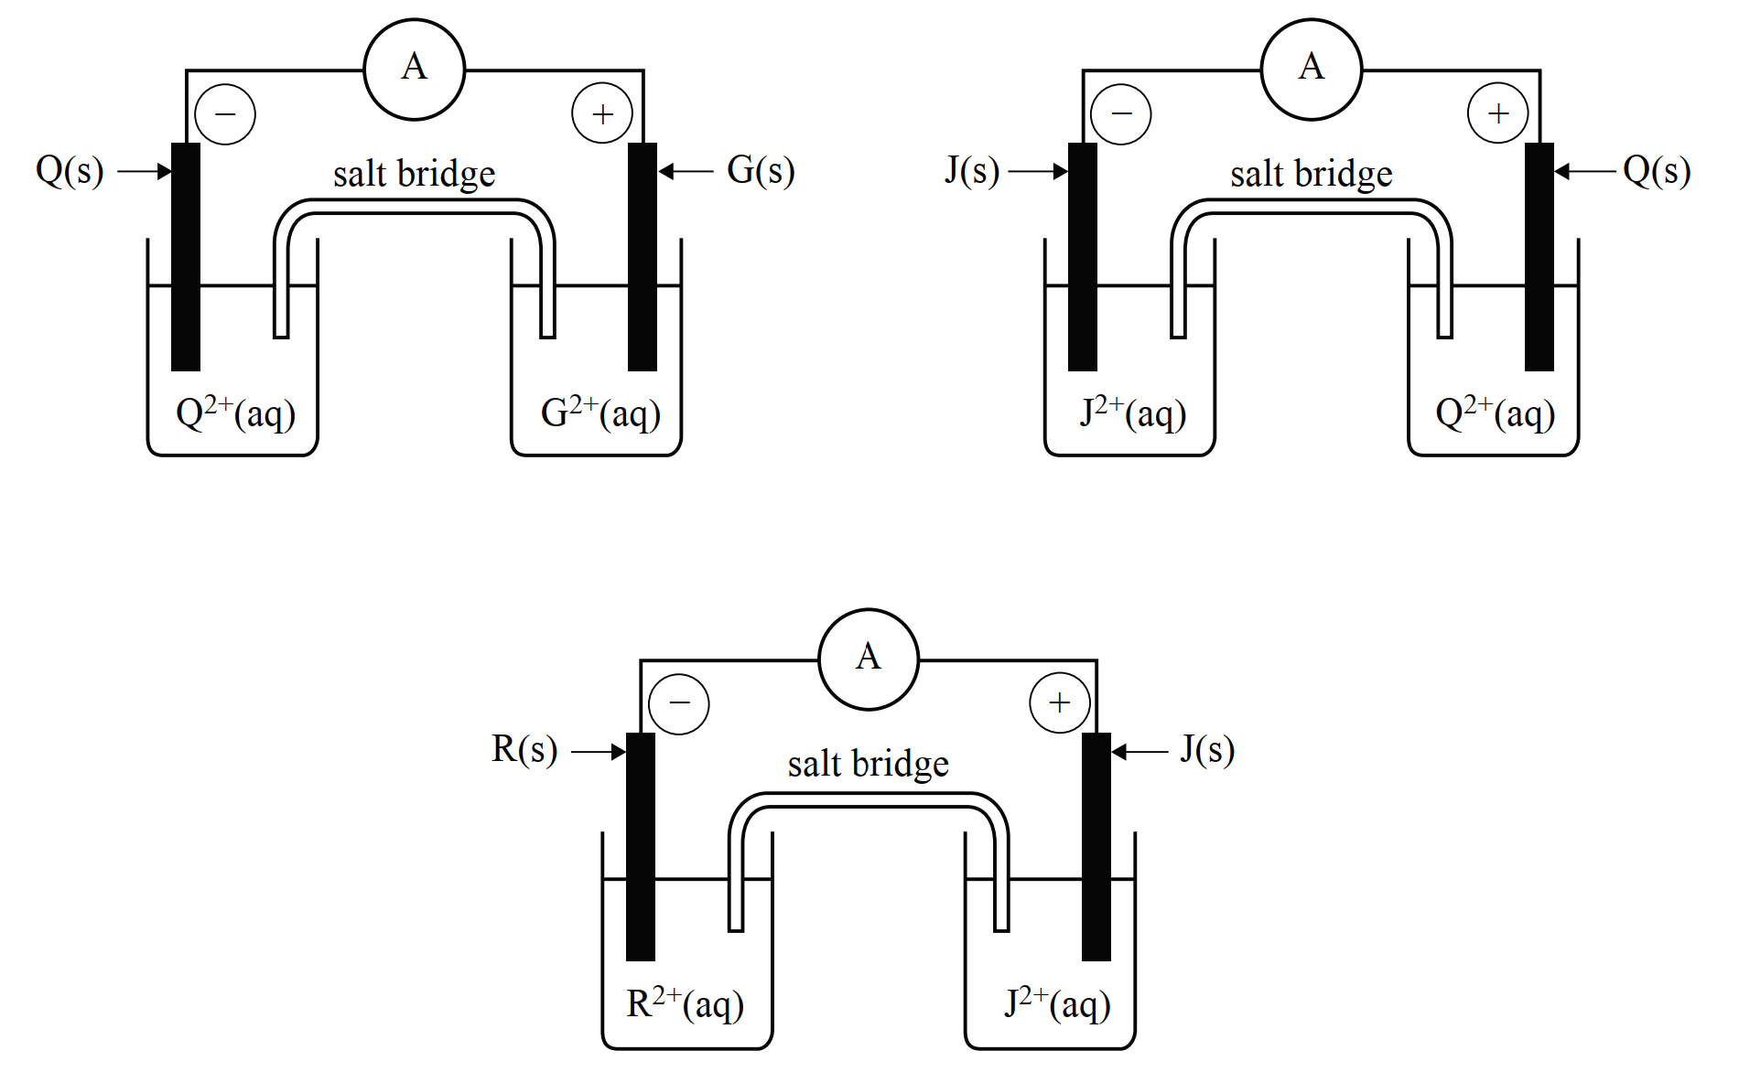

Which of the following indicates the order of the half-cells reactions from the lowest E0 value to the highest?

1. J/J2+, R/R2+, G/G2+, Q/Q2+
2. Q/Q2+, G/G2+, R/R2+, J/J2+
3. R/R2+, J/J2+, Q/Q2+, G/G2+
4. G/G2+, Q/Q2+, J/J2+, R/R2+

20. The following reaction represents the oxidation of thiosulfate (S2O32-) to tetrathionate (S4O62-) by iodine.

I2(aq) + 2 S2O32-(aq) → 2 I-(aq) + S4O62-(aq)

This redox reaction was used as the basis for a galvanic cell and the EMF was measured to be +0.46 V under standard conditions.

What is the value of the standard reduction potential (E0) for the conversion of tetrathionate (S4O62-) to thiosulfate (S2O32-)?

(a) - 0.08 V

(b) + 0.08 V

(c) - 1.00 V

(d) + 1.00 V

21. Some weak organic acids, including vitamin C (ascorbic acid) are present in lemon juice and are able to undergo acid-base reactions. Only vitamin C, not the organic acids, will undergo a redox reaction with iodine, I2.

Which one of the following methods would be most appropriate to determine the concentrations of the organic acids and the vitamin C in a sample of lemon juice?

1. an acid-base titration with sodium hydroxide and phenolphthalein indicator.
2. an acid-base titration with ammonia and methyl orange indicator and a titration with iodine and starch indicator.
3. an acid-base titration with sodium hydroxide and methyl orange indicator and a titration with iodine and starch indicator.
4. an acid-base titration with sodium hydroxide and phenolphthalein indicator and a titration with iodine and starch indicator.

22. Consider the following gaseous equilibrium system;

2 NO2(g) ⇌ N2O4(g)

The **solid** lines on the following graph represent the establishment of equilibrium under a particular set of conditions for this system.

equilibrium established (dashed lines)

equilibrium established (solid lines)

Time

Reaction rate

Forward

Forward

Reverse

Reverse

Which of the following changes to this system would **not** result in the establishment of a new equilibrium as indicated by the **dashed** lines?

(a) An increase in the temperature of the system.

(b) A decrease in the volume of the system.

(c) The addition of helium gas to the system.

(d) The addition of an appropriate catalyst.

23. Sodium hydrogensulfate was added to a swimming pool to reduce the pH of the water. Which one of the following equations best shows the reaction?

1. HSO4–(aq) + H2O(l) **⇌** OH–(aq) + H2SO4(aq)
2. HSO4–(aq) + H2O(l) **⇌** H3O+(aq) + SO42-(aq)
3. 2HSO4–(aq) + H2O(l) **⇌** H3O+(aq) + H2SO4(aq) + SO42-(aq)
4. Na+(aq) + H2O(l) **⇌** H+(aq) + NaOH(aq)

24. The wet corrosion of iron (Fe) occurs in the presence of oxygen gas (O2) and water (H2O). The iron reacts to become iron(II) ions, Fe2+(aq), whilst the water and oxygen gas form hydroxide ions, OH-(aq). The iron(II) ions and hydroxide ions then precipitate to form iron(II) hydroxide, Fe(OH)2(s). Over time, this precipitate forms iron(III) hydroxide, Fe(OH)3(s) which then dehydrates to form iron(III) oxide, Fe2O3(s), which is commonly called rust.

Which of the following statements is **not** correct, regarding the corrosion process described?

1. The oxidation number of O2 is decreased.
2. The solid Fe loses electrons.
3. The H2O acts as the oxidising agent.
4. The precipitation of Fe(OH)2 is not a redox process.

25. Which pair of substances could react, in the presence of an appropriate catalyst, to form the compound below?











**End of Section One**

**Section Two: Short answer 35% (76 marks)**

This section has **nine (9)** questions. Answer **all** questions. Write your answers in the spaces provided.

Supplementary pages for planning/continuing your answers to questions are provided at the end of this Question/Answer booklet. If you use these pages to continue an answer, indicate at the original answer where the answer is continued, i.e. give the page number.

Suggested working time: 60 minutes.

**Question 26 (11 marks)**

Consider 0.05 mol L-1 solutions of sodium hydrogencarbonate, potassium hydrogensulfate and lithium phosphate. The table below lists these salts, along with Kc values for the corresponding hydrolysis reactions.

|  |  |  |
| --- | --- | --- |
| 0.05 mol L-1 solution | Hydrolysis equation | Kc of hydrolysis reaction |
| NaHCO3(aq) |  | 2.4 x 10-8 |
| KHSO4(aq) |  | 1.2 x 10-2 |
| Li3PO4(aq) |  | 2.3 x 10-2 |

(a) Complete the table above, by writing the hydrolysis equation that would take place in each solution. (3 marks)

(b) Rank these solutions in order from lowest to highest pH. (3 marks)

|  |  |  |
| --- | --- | --- |
| Lowest pH |  | Highest pH |
|  |  |  |

The pH of a lithium carbonate solution, Li2CO3(aq), was tested with a pH meter and determined to be 10.3.

A chemistry student had 8.50 mL of 0.0500 mol L-1 barium hydroxide solution, Ba(OH)2(aq). They wanted to dilute the barium hydroxide so that it would have the same pH as the lithium carbonate solution.

(c) Calculate the volume of water the student would need to add to the barium hydroxide solution, to produce the same pH as the lithium carbonate. (5 marks)

**Question 27 (9 marks)**

Consider the three (3) different polymer fragments shown below.

**A**



**B**



**C**



(a) Classify the polymers as having been formed by addition or condensation polymerisation by writing the letters A, B and C in the appropriate column in the table. (3 marks)

|  |  |
| --- | --- |
| Addition polymerisation | Condensation polymerisation |
|  |  |

(b) Draw the monomer(s) used to form each of these polymers. (6 marks)

|  |  |
| --- | --- |
| A |  |
| B |  |
| C |  |

**Question 28 (10 marks)**

Consider the two redox reactions below.

**Reaction A** Sn2+(aq) + 2 I-(aq) → Sn(s) + I2(aq)

**Reaction B** Sn2+(aq) + Co(s) → Sn(s) + Co2+(aq)

(a) Which reaction relates to a galvanic cell and which relates to an electrolytic cell? Justify your answer. (3 marks)

Reaction _______ relates to a galvanic cell.

Reaction _______ relates to an electrolytic cell.

________________________________________________________________________

________________________________________________________________________

________________________________________________________________________

Using the appropriate reaction (A or B) from above;

(b) Draw a diagram of the experimental set up that could be used to produce a **galvanic cell**. Your diagram should label all the equipment and chemicals required to set up the cell as well as showing electron flow. (Note that labels of electrodes, polarity and ion flow are **not** required.) (4 marks)

(c) Calculate the EMF produced by this galvanic cell, assuming standard conditions. (1 mark)

Using the appropriate reaction (A or B) on the previous page;

(d) State the observations for each electrode if this process was occurring in an **electrolytic cell**. Assume the electrodes are made from graphite. (2 marks)

|  |  |
| --- | --- |
| positive electrode |  |
| negative electrode |  |

**Question 29 (9 marks)**

A key reaction in the Contact process involves the conversion of sulfur dioxide gas to sulfur trioxide gas. This reversible process can be represented by the equation below.

2 SO2(g) + O2(g) ⇌ 2 SO3(g)

The following graph shows the relationship between temperature and percentage conversion of SO2(g) to SO3(g) for this process.

(a) Use the information in the graph provided to determine if this reaction is endothermic or exothermic as written. Justify your answer. (3 marks)

________________________________________________________________________

________________________________________________________________________

________________________________________________________________________

________________________________________________________________________

________________________________________________________________________

________________________________________________________________________

(b) Complete the following table, by stating the **pressure** conditions of the system (high or low) that would result in;

(i) the fastest rate, and

(ii) the highest yield.

Give a brief justification for each of your choices. (5 marks)

|  |  |
| --- | --- |
| (i)  fastest rate | (circle your choice) high OR low |
| Justification |
| (ii)  highest yield | (circle your choice) high OR low |
| Justification |

When this process is carried out industrially, a low pressure of 1-2 atm is used.

(c) Suggest a reason for this. (1 mark)

________________________________________________________________________

________________________________________________________________________

________________________________________________________________________

**Question 30 (7 marks)**

Telluric acid has the formula H6TeO6. In solid form, it is found as white crystals. These crystals dissolve in water to produce hydronium ions, H3O+(aq). The Ka values for telluric acid at 18 °C are given below.

Ka1 = 2.09 x 10-8 Ka2 = 1.00 x 10-11

(a) Classify telluric acid as strong or weak (circle your choice). Justify your answer. (2 marks)

strong OR weak

________________________________________________________________________

________________________________________________________________________

________________________________________________________________________

(b) Label and link the conjugate acid-base pairs in the following equation. (2 marks)

H6TeO6(aq) + HPO42-(aq) ⇌ H2PO4-(aq) + H5TeO6-(aq)

Telluric acid can be produced by the oxidation of solid tellurium dioxide, TeO2(s), by hydrogen peroxide solution. In this reaction, hydrogen peroxide forms water.

(c) Write the oxidation and reduction half-equations and the overall redox equation for this reaction, assuming acidic conditions. (3 marks)

|  |  |
| --- | --- |
| Oxidation half-equation |  |
| Reduction half-equation |  |
| Overall redox equation |  |

**Question 31 (6 marks)**

(a) Give the IUPAC names for isomers of C3H6O2 matching each description below. (2 marks)

|  |  |
| --- | --- |
|  | IUPAC Name |
| A sweet or fruity smelling liquid |  |
| A weak electrolyte with a pH below 7 |  |

(b) Give the IUPAC names for isomers of C5H12O matching each description below. (2 marks)

|  |  |
| --- | --- |
|  | IUPAC Name |
| A primary alcohol |  |
| A tertiary alcohol |  |

(c) Draw full structural diagrams for isomers of C4H8O matching each description below. Include **all** bonds and **all** atoms. (2 marks)

|  |  |
| --- | --- |
| A compound that can be oxidised by acidified KMnO4 solution | A compound that cannot be oxidised by acidified KMnO4 solution |
|  |  |

**Question 32 (12 marks)**

The following equilibrium system exists in ocean water and shows the relationship between several of the carbon-species present.

Ca2+(aq) + 2 HCO3-(aq) + heat ⇌ CaCO3(s) + H2O(l) + CO2(g)

The forward reaction represents the process of ‘**calcification’**, where solid CaCO3 forms. The reverse process represents the ‘**dissolution’** of solid CaCO3.

(a) Write the equilibrium constant (K) expression for this system. (1 mark)

|  |
| --- |
|  |

The large quantity of CO2(g) produced and released into our atmosphere by human activity is having an effect on the carbon equilibria in our oceans.

(b) Explain, in terms of the collision theory and reaction rates, how this increase in the partial pressure of atmospheric CO2(g) affects the calcification process. Your answer should refer to the equation above. (3 marks)

________________________________________________________________________

________________________________________________________________________

________________________________________________________________________

________________________________________________________________________

________________________________________________________________________

(c) State **two (2)** consequences for calcifying species that may result from this increase in the partial pressure of atmospheric CO2(g). (2 marks)

________________________________________________________________________

________________________________________________________________________

________________________________________________________________________

________________________________________________________________________

(d) Write a three-step reaction sequence, showing how an increased partial pressure of atmospheric CO2(g) leads to a decrease in ocean pH. (3 marks)

|  |  |
| --- | --- |
| Step 1 |  |
| Step 2 |  |
| Step 3 |  |

CaCO3(s)

H2O(l), HCO3-(aq), Ca2+(aq)

CO2(g)

plunger

An artificial replica of this equilibrium system was set up in a closed container, which was sealed with a moveable plunger, allowing for variable gas volume and pressure to be achieved. The set up is illustrated in the diagram to the right.

(e) Consider the effect of imposing the following changes on the system. Complete the table below by stating whether the process of calcification or dissolution or neither is favoured. (3 marks)

|  |  |
| --- | --- |
|  | Favoured process  (calcification / dissolution / neither) |
| The volume of the system is decreased by pushing the plunger down |  |
| Additional CaCO3(s) is added to the system |  |
| The temperature of the system is increased |  |

**Question 33 (6 marks)**

Consider the distinguishing chemical tests described below.

(a) Write **observations** for the following test, which can be used to distinguish between solutions of sodium chloride and sodium iodide. (2 marks)

|  |  |
| --- | --- |
|  | Bromine water, Br2(aq), is added to each |
| NaCl(aq) |  |
| NaI(aq) |  |

(b) Write an **ionic equation**, or state ‘no observable change’, for the following test which can be used to distinguish between solutions of silver nitrate and zinc sulfate. (3 marks)

|  |  |
| --- | --- |
|  | A piece of nickel metal, Ni(s), is added to each |
| AgNO3(aq) |  |
| ZnSO4(aq) |  |

(c) Name or give the formula of a substance that could be added to each solution, to produce the observations given for the following distinguishing test. (1 mark)

|  |  |
| --- | --- |
|  | Substance added: |
| HCHO(aq) | White powder mixed with colourless solution.  No observable changes noted. |
| HCOOH(aq) | White powder mixed with colourless solution. White powder  dissolves and colourless, odourless gas is produced. |

**Question 34 (6 marks)**

Benzoic acid is found in many berries and some other fruits, and is used as a food preservative.  
The structure of benzoic acid is shown below. In an aqueous environment, benzoic acid  
ionises and exists in equilibrium with the benzoate ion.

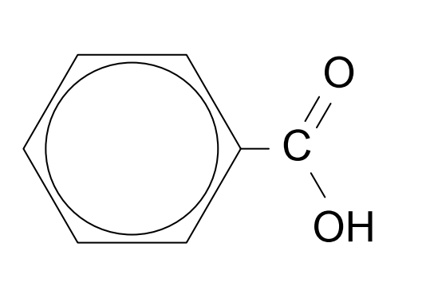

(a) Write the equation for the reaction between benzoic acid and water. Show all atoms.

(1 mark)

(b) The ease with which a substance is excreted from the body is determined in part by its solubility in water. Is benzoic acid more or less miscible with water than acetic (ethanoic) acid, and hence more or less readily excreted from the body? Explain, in detail, your choice.(5 marks)

________________________________________________________________________________________________________________________________________________________________________________________________________________________________________________________________________________________________________________________________________________________________________________________________________________________________________________________________________________________________________________________________________________________________________________________________________________________________________________

________________________________________________________________________________________________________________________________________________________________________________________________________________________________________________________________________________________________________________________

________________________________________________________________________________________________________________________________________________________________________________________________________________________________________________________________________________________________________________________

**End of Section Two**

**Section Three: Extended answer 40% (97 marks)**

This section contains **six (6)** questions. You must answer **all** questions. Write your answers in the spaces provided below.

Where questions require an explanation and/or description, marks are awarded for the relevant chemical content and also for coherence and clarity of expression. Lists or dot points are unlikely to gain full marks.

Final answers to calculations should be expressed to the appropriate number of significant figures.

Supplementary pages for planning/continuing your answers to questions are provided at the end of this Question/Answer booklet. If you use these pages to continue an answer, indicate at the original answer where the answer is continued, i.e. give the page number.

Suggested working time: 70 minutes.

**Question 35 (18 marks)**

The following reversible reaction between chromate (CrO42-) and dichromate (Cr2O72-) was set up in a beaker and allowed to establish equilibrium. The initial colour of the equilibrium system was a light orange. The equilibrium can be represented by the following equation;

2 CrO42-(aq) + 2 H+(aq) ⇌ Cr2O72-(aq) + H2O(l)

*yellow orange*

This equilibrium system is ‘pH dependent’.

(a) Complete the following table, by writing the colour this equilibrium system would appear at both a low and a high pH. (1 mark)

|  |  |
| --- | --- |
| Colour at low pH | Colour at high pH |
|  |  |

The equilibrium mixture was then divided equally into 2 smaller beakers. The separate beakers, Beaker 1 and Beaker 2, were treated as described below.

**Beaker 1**

* 10 drops of 2 mol L-1 HCl(aq) were added at Time T1, and equilibrium was re-established at Time E2.

You may assume the increase in volume due to the added HCl(aq) is negligible.

The following graph represents the equilibrium in Beaker 1.

2 CrO42-(aq) + 2 H+(aq) ⇌ Cr2O72-(aq) + H2O(l)

Cr2O72-(aq)

CrO42-(aq)

H+(aq)

E1 T1 E2 T2

(b) Plot the concentration for each of the ions shown on the graph, from Time T1 to Time T2. (4 marks)

**Beaker 2**

The following graph represents the equilibrium in Beaker 2.

2 CrO42-(aq) + 2 H+(aq) ⇌ Cr2O72-(aq) + H2O(l)

The volume of the solution in Beaker 2 was doubled by adding some distilled water at Time T1 and equilibrium was re-established at Time T2.

E1 T1 E2 T2

Cr2O72-(aq)

E1 T1 E2 T2

(c) Plot the concentration for each of the ions shown on the graph, from Time T1 to Time T2.

(4 marks)

(d) Justify the subsequent equilibrium shift in Beaker 2 using Le Chatelier’s Principle. (3 marks)

________________________________________________________________________

________________________________________________________________________

________________________________________________________________________

________________________________________________________________________

________________________________________________________________________

________________________________________________________________________

________________________________________________________________________

At Time T2, Beaker 2 was placed into an ice bath. Over several minutes, the equilibrium became a more yellow colour.

(e) Explain what information this provides about the heat of reaction (H) for this equilibrium system. (3 marks)

________________________________________________________________________

________________________________________________________________________

________________________________________________________________________

________________________________________________________________________

________________________________________________________________________

________________________________________________________________________

________________________________________________________________________

________________________________________________________________________

(f) Complete the reaction rate graph below, for both the forward and reverse reaction rates, from Time T2 until the re-establishment of equilibrium at Time E3. (3 marks)

forward

reverse

______

_ _ _ _

l l

T2 E3

Time

Reaction rate

forward

reverse

**Question 36 (15 marks)**

In traditional Aboriginal culture, native plants have been used for many generations to treat or heal those who are sick or injured. Research is now being carried out on many of the various plants that were used by Aboriginal peoples and has found that they often contain well known anti-bacterial or anti-inflammatory compounds.

The table below gives information on three (3) compounds that have been identified in native Australian plants which were used by Aboriginal peoples to treat various medical conditions.

|  |  |  |  |
| --- | --- | --- | --- |
| **Name of compound** | Terpinenol | Eugenol | Pinene |
| **Extracted from** | Tea tree oil | Australian lemongrass | Eucalyptus oil |
| **Aboriginal medicinal use** | treating wounds and throat ailments | treating headaches, colds and muscle pain | treating body pain, fever and chills |
| **Structure** |  |  |  |

A chemist was given a pure sample of each of these 3 compounds for analysis. However, the samples were not labelled.

(a) Explain why the addition of bromine water to each of these samples would **not** be a useful distinguishing test. (2 marks)

________________________________________________________________________

________________________________________________________________________

________________________________________________________________________

________________________________________________________________________

________________________________________________________________________

The compound ‘pinene’ could quickly be distinguished from the other two compounds by adding a few drops of acidified sodium dichromate solution to each.

(b) Justify how this test would allow for the identification of pinene, including relevant observations in your answer. (Note that equations are **not** required.) (3 marks)

________________________________________________________________________

________________________________________________________________________

________________________________________________________________________

________________________________________________________________________

________________________________________________________________________

________________________________________________________________________

The chemist then used combustion analysis to distinguish ‘terpinenol’ and ‘eugenol’. A 7.58 g sample of one of the compounds was taken for analysis. Upon combustion, 20.33 g of carbon dioxide and 4.99 g of water vapour was produced.

(c) Determine the empirical formula of this sample and identify which compound was being analysed. (8 marks)

The chemist then carried out two further chemical tests with the compound identified by combustion analysis in part (c).

(d) Draw structural diagrams (showing all atoms) for the resulting organic compound formed when the substance identified in (c) reacts

(i) with bromine water

(ii) with acidified sodium dichromate. (2 marks)

|  |  |  |
| --- | --- | --- |
|  | bromine water, Br2(aq) | chemical test described in part (b) |
| Organic product formed |  |  |

**Question 37 (13 marks)**

A beaker contained 135 mL of 2.73 mol L-1 hydrochloric acid, HCl(aq). A group of chemistry students were given some 1.98 mol L-1 ammonia solution, NH3(aq), and asked to neutralise the acid.

They measured 344 mL of the ammonia solution and poured it into the beaker containing the hydrochloric acid. The equation for the reaction that took place is given below.

HCl(aq) + NH3(aq) → NH4Cl(aq)

(a) Calculate the final concentration, in mol L-1, of any excess reagent present. (5 marks)

(b) Calculate the final concentration, in mol L-1, of ammonium chloride product. (2 marks)

One of the chemistry students in the group proposed that the final mixture in the beaker would act as a buffer solution.

(c) Was this student correct? Justify your answer using relevant chemical theory. Include a brief description of how the student’s hypothesis could be tested experimentally. (6 marks)

________________________________________________________________________

________________________________________________________________________

________________________________________________________________________

________________________________________________________________________

________________________________________________________________________

________________________________________________________________________

________________________________________________________________________

________________________________________________________________________

________________________________________________________________________

________________________________________________________________________

________________________________________________________________________

________________________________________________________________________

________________________________________________________________________

________________________________________________________________________

________________________________________________________________________

________________________________________________________________________

________________________________________________________________________

**Question 38 (25 marks)**

An ongoing area of chemical research relates to the optimisation of biodiesel production from the triglycerides in waste vegetable oil. The chemical process involves converting waste vegetable oil into biodiesel in a reaction catalysed by sodium hydroxide (NaOH). A common component found in waste vegetable oil is the triglyceride ‘triolein’. The structure of triolein is shown below.



(a) What is biodiesel? Describe how triolein can be converted into biodiesel, by naming the chemical reaction and stating the additional reactant required. (3 marks)

________________________________________________________________________

________________________________________________________________________

________________________________________________________________________

________________________________________________________________________

________________________________________________________________________

________________________________________________________________________

________________________________________________________________________

________________________________________________________________________

One of the problems associated with converting waste vegetable oil into biodiesel, is that the vegetable oil can often contain a high levels of free fatty acids (FFAs). In the case of triolein, when heated for use in cooking it can produce ‘oleic acid’, CH3(CH2)7CH=CH(CH2)7COOH.

The ‘percent free fatty acid’ (% FFA) of vegetable oil is calculated as the grams of FFA present per 100 g of oil. The concentration of FFA in any oil, is generally calculated and stated in terms of ‘oleic acid’, as this is a common fatty acid of average molecular weight.

i.e. % FFA = m(oleic acid) x 100

m(oil)

When making biodiesel, if the waste vegetable oil contains greater than 1% FFA by mass, extra sodium hydroxide must be added to the reaction mix. This ensures that the FFAs are completely neutralised and that there is still enough sodium hydroxide left over to act as a catalyst in the formation of biodiesel.

(b) Write the equation for the reaction of oleic acid with sodium hydroxide. (2 marks)

|  |
| --- |
|  |

(c) Give the **general** name for the type of organic substance produced in (b). (1 mark)

________________________________________________________________________

A particular batch of waste vegetable oil from a restaurant was being analysed for FFA content before being converted into biodiesel. The amount of sodium hydroxide required to neutralise the FFAs present in a sample of waste vegetable oil is determined by titration.

A 10.00 mL sample of the waste vegetable oil was taken and mixed with 100.0 mL of propan-2-ol. 15.00 mL aliquots of the diluted oil were then titrated against 0.01180 mol L-1 NaOH(aq). This required an average titre of 10.66 mL. The density of the waste vegetable oil was 0.8950 g mL-1.

(d) Calculate the % FFA in this batch of waste vegetable oil. (6 marks)

(The molecular mass of oleic acid is 282.452 g mol-1.)

(e) State **two (2)** reasons for performing repeat trials in a titration, in order to obtain an average titre. (2 marks)

________________________________________________________________________

________________________________________________________________________

________________________________________________________________________

(f) If the burette had been rinsed with water before use in this titration, state the effect this would have had on the calculated % FFA content. Justify your answer. (2 marks)

________________________________________________________________________

________________________________________________________________________

________________________________________________________________________

________________________________________________________________________

The standard amount of solid sodium hydroxide catalyst, NaOH(s), added to the reaction mix during biodiesel production, is 3.50 g per litre of vegetable oil, **plus** any extra NaOH that is required to neutralise the FFAs present.

A 2500.0 L batch of the waste oil from the restaurant was to be converted to biodiesel.

(g) Calculate the total mass of NaOH needed for this reaction mixture. (5 marks)

An alternate catalyst for the production of biodiesel by this method is the enzyme lipase.

(h) State **two (2)** similarities and **two (2)** differences in the way the NaOH and lipase catalysts function in this process. (4 marks)

|  |  |
| --- | --- |
| **Similarities** | |
| 1 |  |
| 2 |  |
| **Differences** | |
| 1 |  |
| 2 |  |

**Question 39 (18 marks)**

With an emphasis on the principles of green chemistry becoming essential in our modern world, this has led to many new areas of research. One particular type of fuel cell, the ‘high temperature carbonate fuel cell’ has been designed so that it can be powered by biogas (a mixture of methane and carbon dioxide gases).

High temperature carbonate fuel cells are often built at landfill sites where biogas is already being produced. As microbes digest organic waste they produce methane in a process called ‘methanogenesis’. This is performed by bacteria called methanogens, which convert the glucose found in landfill into biogas.

*Step 1*: C6H12O6(s) → 3 CO2(g) + 3 CH4(g)

The carbon dioxide is removed from the biogas and the methane is then used in the carbonate fuel cell where it reacts with water to produce hydrogen gas.

*Step 2*: CH4(g) + H2O(g) → 3 H2(g) + CO(g)

The hydrogen gas is then reacted with oxygen gas in the fuel cell to produce electrical energy.

*Step 3*: 2 H2(g) + O2(g) → 2 H2O(l)

The process of methanogenesis (i.e. Step 1) is catalysed by various enzymes (proteins) present in the bacteria. These enzymes are sensitive to both temperature and pH.

(a) With reference to **tertiary structure**, explain why enzymes generally only function within a narrow temperature and pH range. (5 marks)

________________________________________________________________________

________________________________________________________________________

________________________________________________________________________

________________________________________________________________________

________________________________________________________________________

________________________________________________________________________

________________________________________________________________________

________________________________________________________________________

________________________________________________________________________

________________________________________________________________________

________________________________________________________________________

One of the principles of green chemistry involves maximising atom economy. Atom economy is a measure of the proportion of reactant atoms that are converted into the desired product in the chemical reaction.

(b) Calculate the percent atom economy of Step 1. (2 marks)

High temperature carbonate fuel cells produce 135 kg of hydrogen gas per day using this method. The yield of Step 1 is 94.2% and the yield of Step 2 is 86.8%.

(c) Calculate the mass of glucose required **each day** to produce this hydrogen. State your answer to the appropriate number of significant figures. (6 marks)

(d) Calculate the volume of air, collected at 15.0 °C and 97.6 kPa, that would be required **each day** to supply sufficient oxygen to react with this hydrogen. Assume air is composed of 21.0% oxygen gas by volume. (3 marks)

(e) Write separate half-equations for the oxidation and reduction processes taking place in Step 1 (assuming acidic conditions). (2 marks)

|  |  |
| --- | --- |
| Oxidation  half-equation |  |
| Reduction  half-equation |  |

**Question 40 (8 marks)**

Consider the wind power farm below.

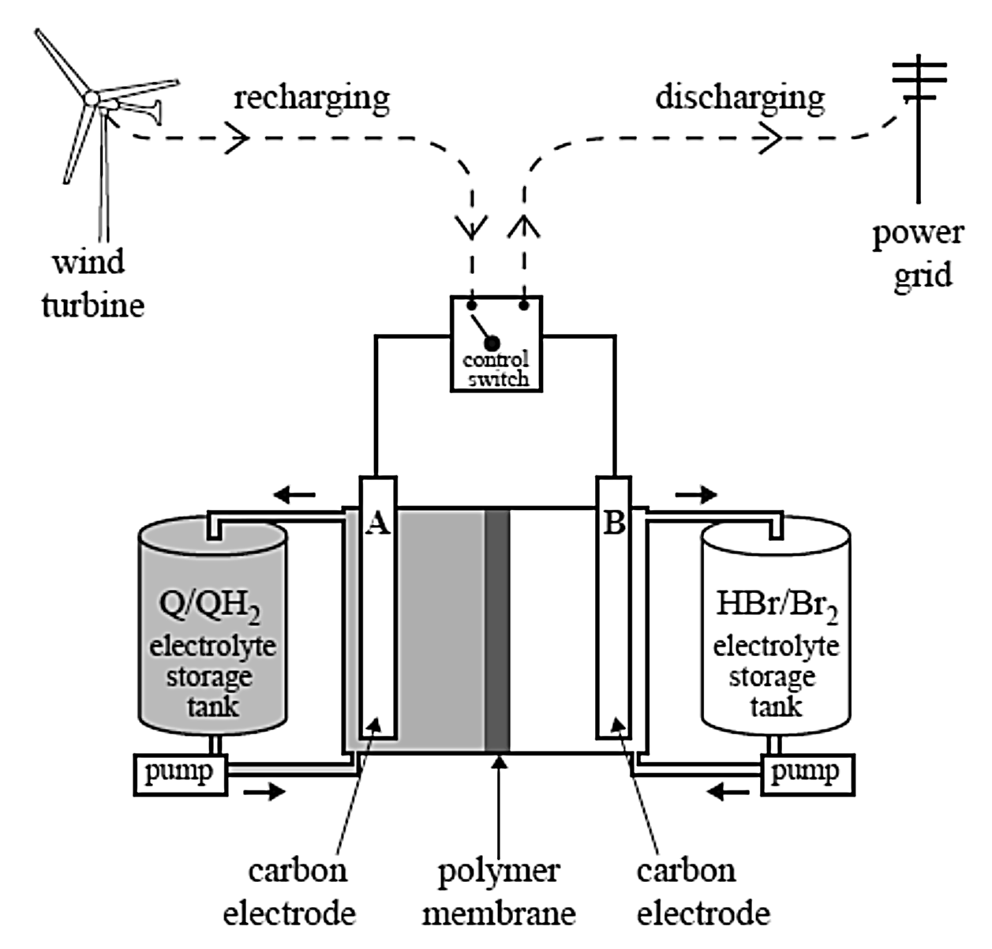

The batteries are recharged using electricity generated by the wind turbines or solar cells. A scientific report, published in January 2014, described a redox flow battery that used a family of chemicals commonly occurring in plants such as rhubarb. These are organic and are known as quinones and hydroquinones. A diagram showing how such a redox flow battery might operate is shown above.

In the diagram, Q represents the quinone and QH2 represents the corresponding hydroquinone. The researchers made a model of the redox flow battery using aqueous solutions of the redox pairs, Q/QH2 and Br2/HBr. Refer to the diagram above. During discharge, QH2 is converted to Q and Br2 is converted to HBr.

(a) Write balanced half-equations for the reactions occurring at the positive and negative electrodes as the cell is discharged. (2 marks)

Positive electrode:

Negative electrode:

(b) Write the overall reaction when the cell is recharged. (1 mark)

(c) The researchers reported that their tests indicated that only hydrogen ions were able to move through the polymer membrane separating the cells.

(i) Use an arrow (→ or ←) to indicate the direction of movement of hydrogen ions as the cell is recharged. (1 mark)

(ii) Why is it important that the other reactants in the half-cells are not able to pass through the polymer? (2 marks)

________________________________________________________________________________________________________________________________________________________________________________________________________________________

(d) The researchers also reported that the voltage applied to the cell during recharging was kept below 1.5 V to avoid the electrolysis of water. Write the reduction and oxidation half-equations that occur when water is electrolysed. (2 marks)

Oxidation:

Reduction:

**End of Questions**

Spare answer page

Question number: ___________________

Spare answer page

Question number: ___________________

Spare answer page

Question number: ___________________

**Acknowledgements**

Q 17 Orange carotenoid protein

<http://www.ebi.ac.uk/> Under the Public Domain – Creative Commons Attribution-ShareAlike License

Q 39 Wind power farm

<http://www.dynamicscience.com.au/tester/solutions1/chemistry/pastexamquestion/2014galvanic.html>